CUSTOMER CHURN PREDICTION - IMAGES AND OUTPUTS
STEP 2 – LOAD DATASET
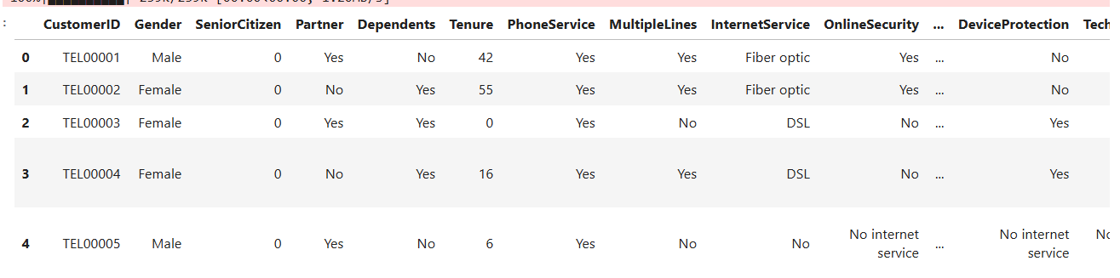
This is preview of first five rows after loading the data.
STEP 6- EXPLORATORY DATA ANALYSIS(EDA)
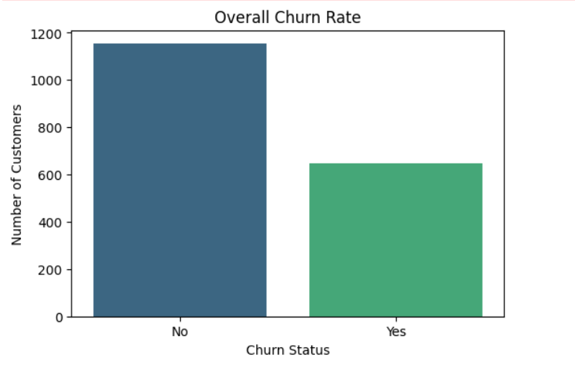
The chart indicates that most customers in the telecom churn dataset remained with the company, while a smaller proportion discontinued the service. This suggests overall customer retention is stable, but the noticeable churn rate highlights the need to identify factors influencing customer loss and improve retention strategies.
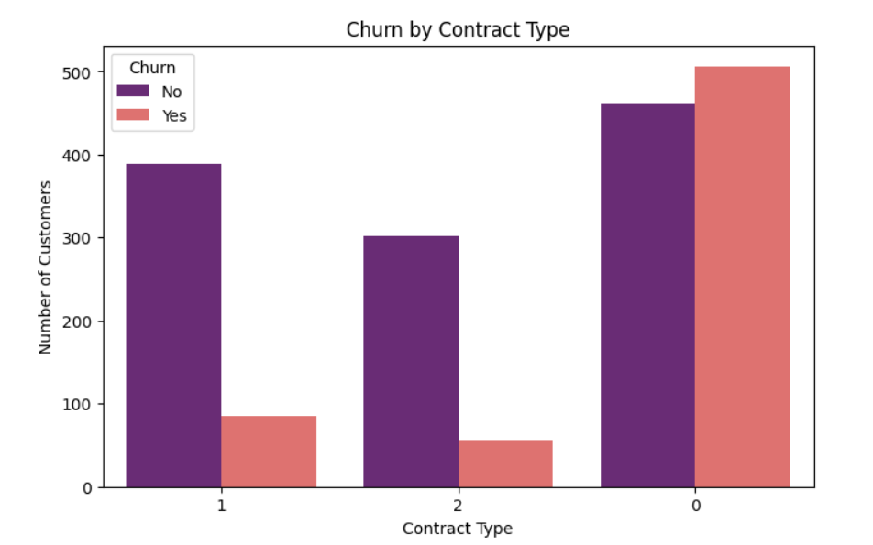
The chart shows that customers with longer-term contracts (Types 1 and 2) are less likely to churn, while customers with Contract Type 0 have the highest churn rate. This suggests that shorter or less committed contracts are strongly associated with higher customer attrition in the dataset.
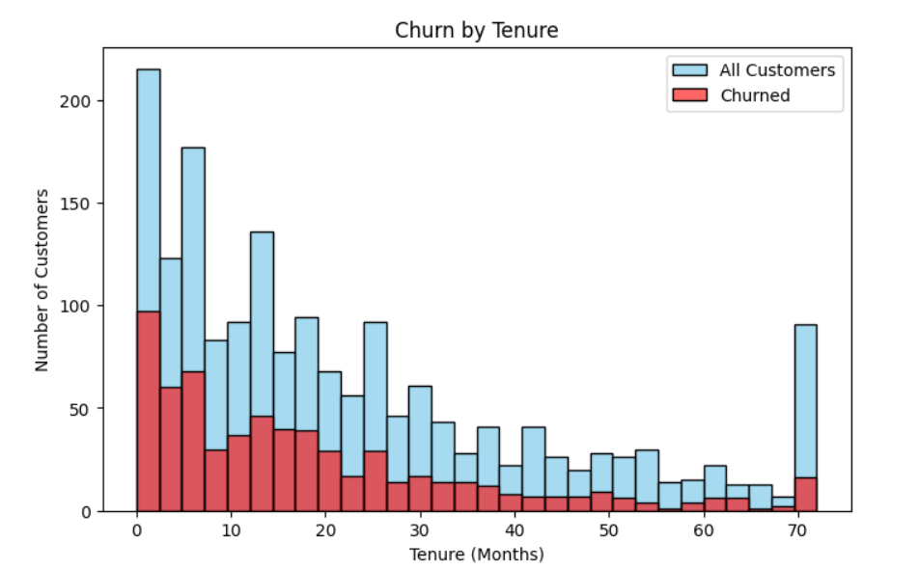
The histogram indicates that customers with shorter tenure are more likely to churn, as the highest churn counts occur during the early months of service. In contrast, customers with longer tenure show lower churn rates, suggesting that customer loyalty increases over time.
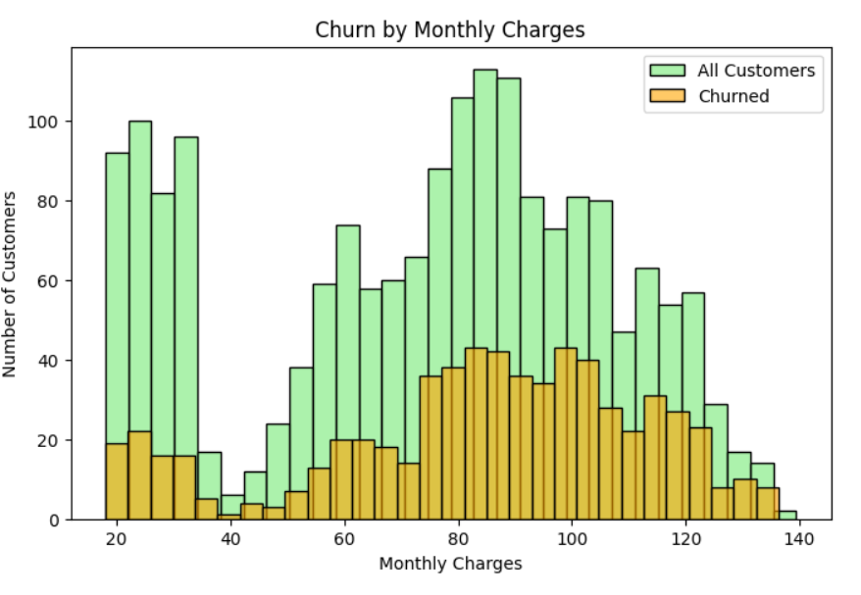
The graph shows that most churned customers fall in the mid-range monthly charges (70–100). While overall customers are spread across all charge levels, churned users cluster more in this band. This indicates that customers paying mid-level fees are more likely to leave the service.
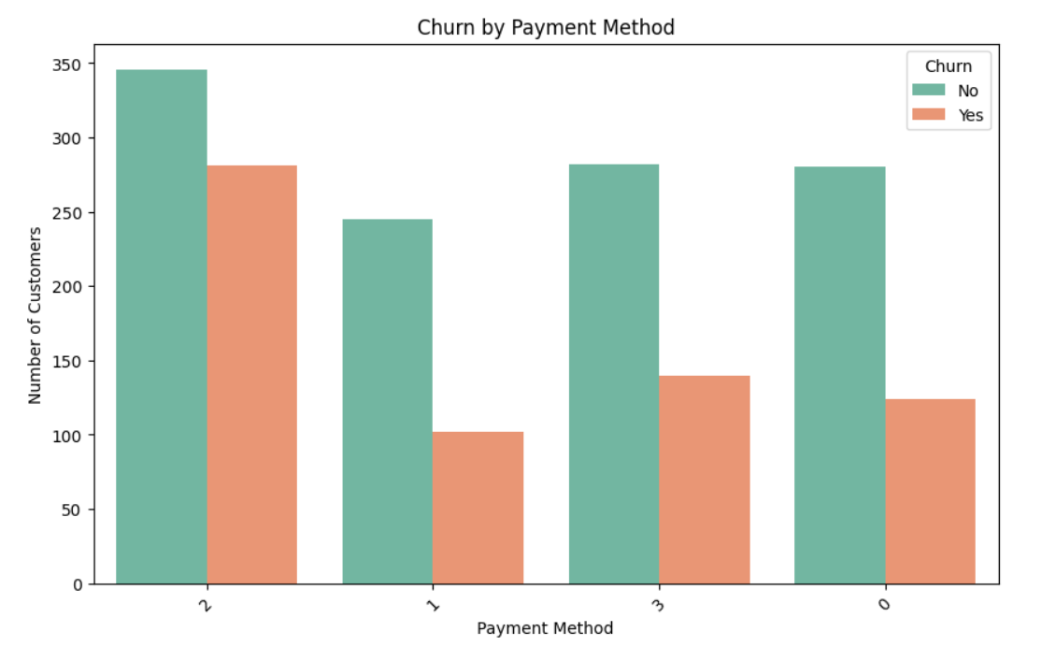
The chart shows that churn varies across payment methods, with some methods having noticeably higher customer loss. Payment method 2 has the largest customer base but also a significant number of churned users, while method 1 shows the lowest churn. This suggests that the way customers pay may influence their likelihood of staying or leaving.
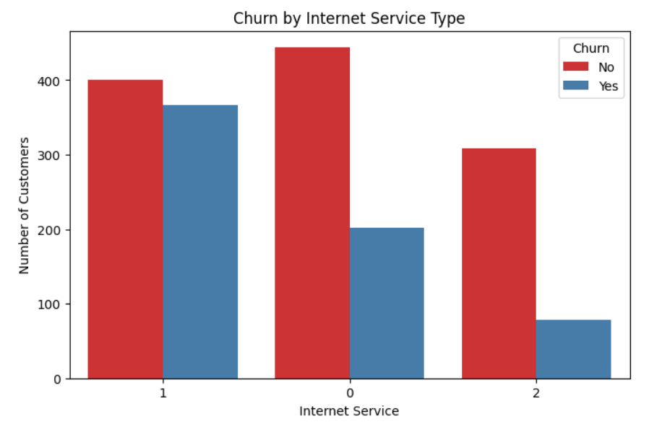
The chart shows that across all internet service types, most customers stay while a smaller portion churns. Service type 0 has the largest number of retained customers, but churn is present in every category. This suggests that churn is influenced by factors beyond just the type of internet service.
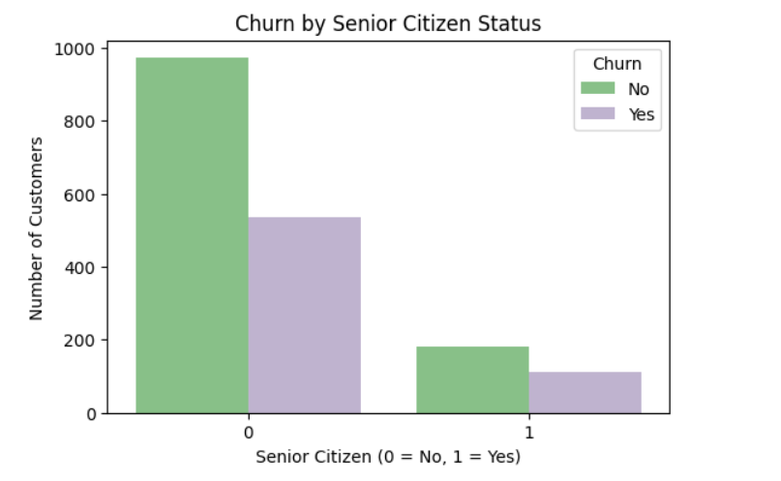
This chart shows that most customers are not senior citizens, and among them, a significant portion has churned. Senior citizens form a smaller group overall, but their churn rate is also notable, indicating that age may have some influence on customer retention.

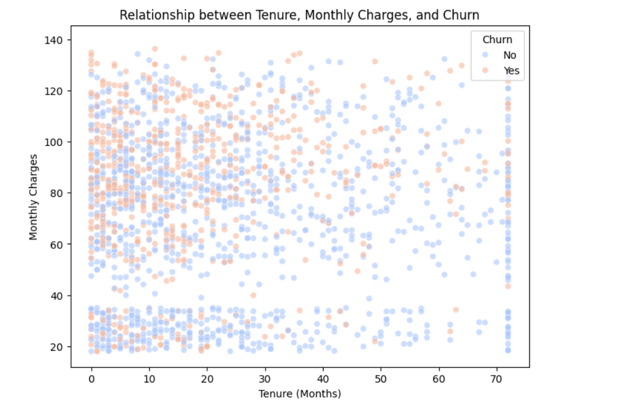
This scatter plot illustrates that customers with shorter tenure and higher monthly charges are significantly more likely to churn. As tenure increases, the concentration of churned customers (orange dots) thins out, suggesting that long-term loyalty helps mitigate the impact of pricing.
STEP 7- MODEL BUILDING
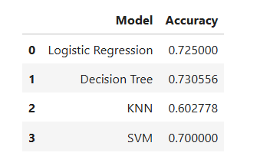
The Decision Tree model is the top performer with the highest accuracy of approximately 73.1%. Conversely, KNN lags behind the others significantly, yielding the lowest accuracy at roughly 60.3%.
STEP 8 -MODEL EVALUATION
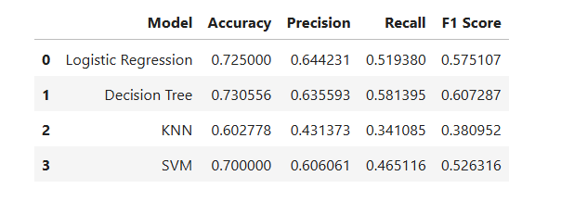
The Decision Tree continues to lead as the most balanced model, boasting the highest Accuracy (73.1%), Recall (58.1%), and F1 Score (60.7%). While Logistic Regression has a slightly higher Precision, the Decision Tree’s superior F1 Score makes it the better choice for overall predictive performance.
STEP 9 – CHURN RISK INTERPRETATION
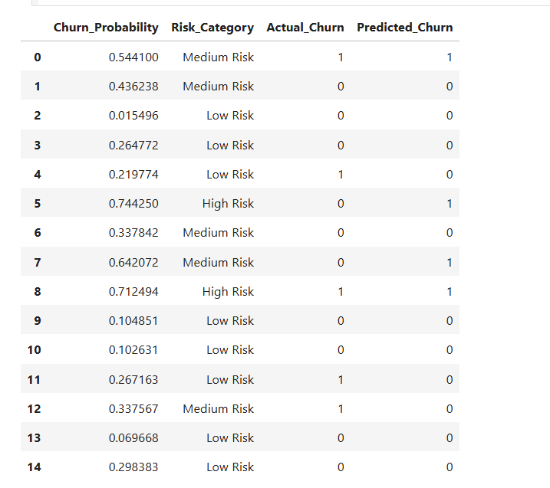
A concise overview of the predictive results.
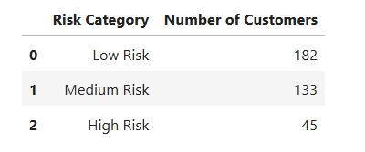
The data shows a healthy distribution where Low Risk customers make up the largest group (182). Targeted intervention should focus on the 45 High Risk individuals and the 133 Medium Risk customers to prevent imminent churn.
STEP 10- RETENTION RECOMMENDATION
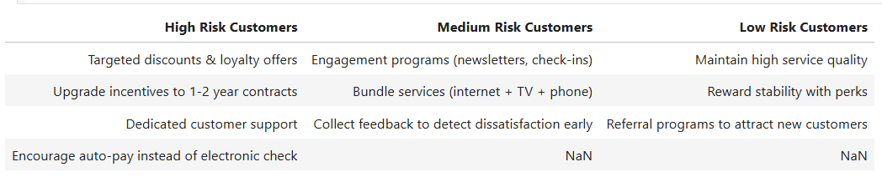
This table outlines tailored retention strategies: High Risk customers receive aggressive incentives like discounts and contract upgrades, Medium Risk focus on engagement and bundling, and Low Risk are rewarded for stability to encourage referrals. It transitions from high-touch intervention to passive relationship maintenance based on churn probability.

